Received 00th January 20xx,

Electronic Supplementary Information (ESI) available: https://github.com/Sauerbac/EEA

Accepted 00th January 20xx

DOI: 10.1039/x0xx00000x

www.rsc.org/

Increasing lifetime of polymer electrolyte membranes by incorporation of metal scavengers – A Review

Simon Auerbach

Fuel cells (FCs) are seen as an important component of a sustainable energy economy of the future. In polymer electrolyte membrane fuel cells (PEMFCs) the membrane plays a key role in providing a effective and long-lastingpower source. Various mechanisms lead to the degradation of PEMs, with the chemical degradation caused by radicals produced in the fuel cell having a major influence. Radcial scavenging has proven to be a good approach to significantly increase lifetime and maintain performance. By incorporating metal oxides, a runtime extension from 200h to well over 1000h has been shown in accelerated stress test, as well as a significant decrease in the fluoride emission rate (FER).

Introduction

In a world where the effects of climate change and its consequences are increasingly being felt, and dependence on fossil fuels from countries such as Russia is leading to heated political discussions, hydrogen represents an important part of an independent, green energy economy.

In addition to production and storage, the efficient conversion of hydrogen to electricity using fuel cells is crucial. To make hydrogen cost-competitive, fuel cells must have a longer life than is currently the case to enable widespread applications in the automotive industry or in stationary power plants, for example.

PEMFCs represent a promising technology to meet these demands. One of the main reasons limiting their lifetime is the degradation of the PEM. Most PEMs available today are made out of perfluorosulfonic acid polymer (PFSA), which enables proton conductivity, acts as an electrical insulator and separates Hydrogen and Oxygen between the two electrodes of a FC1.

In addition to damage caused by mechanical stress, which is caused by different working conditions and humidity, for example, chemical decomposition is seen as a further important aspect. During operation, the PEM is chemically attacked by radicals generated at the electrodes and thus increasingly loses its function, which ultimately leads to the failure of the FC2. Limiting the degradation of such membranes is a key goal in developing cost-effective FCs. It has been shown that the incorporation of so-called scavengers, based on metal oxides, can significantly slow down the chemical degradation and thus significantly extend the lifetime of PEMFCs. These additives are able to quench the radicals by either donating or accepting electrons, preventing them from attacking the membrane, which otherwise would lead to degradation and the emission of fluoride which is of core importance in PEMs3.

Three approaches are discussed, two of which are based on the incorporation of Cerium oxide (CeO2/Ceria) and one on the incorporation of cobalt, chromium and manganese oxides, respectively. In an accelerated open-voltage stress test, all show significant life extension, a decrease in fluoride emission, and little, if any, measurable effect on performance.

Results

Lim et al.4 prepared the baseline membrane electrode assembly (MEA) by hot-pressing standard PFSA membranes with electrode gas diffusion layers (GDLs), which were prepared on sight, as described in their publication. To investigate the effect of incorporating CeO2 on FCs the same GDEs were coated with a solution containing commercial ceria powder. The concentration of the ceria was controlled to be higher at the anode, compared to the cathode. To determine the lifetime of the different MEAS, an accelerated stress test (AST) was performed at open cell voltage (OCV), which is used to evaluate membrane degradation. The applied conditions maximize partial pressures of the reaction gases and hydrogen crossover, as well as promoting a high electrochemical potential at the cathode5. Figure 1 shows that while the baseline MEA failed after 186 hours the CeO2-MEAs lifetime extended to 1244 hours, which is six times as long. The same trend was observed for the FER and the corresponding thicknesses of the MEAs. Degradation of the membranes by radicals leads to fluoride being released from the polymer and therefore leads to loss of material.

At the end of life, the baseline MEAs thickness was only 52 % compared to the start, whereas the MEA with cerium only lost about 10 % of its original thickness. At the end of life, the FER was 40 times lower.

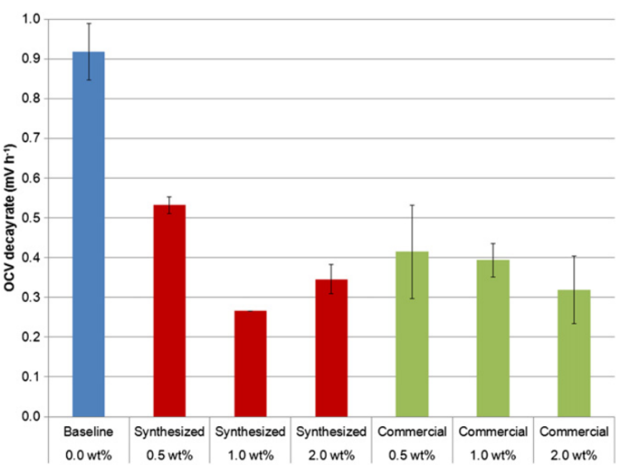

Figure 2: Average OCV decay rate in 94 OCV AST3

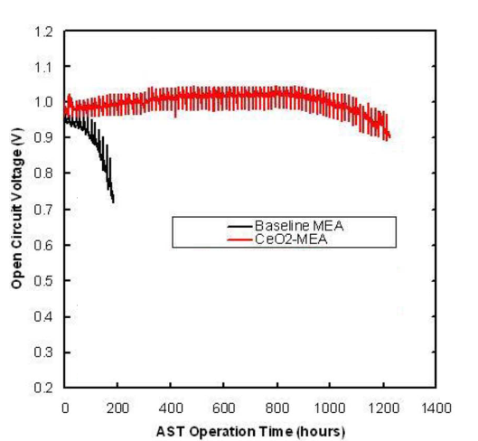

Figure 1: OCV under AST conditions for baseline and ceria loaded MEAs, adapted from Lim at al.4

This directly correlates with the mechanical properties of the membrane. The ceria sample membrane effectively kept its mechanical properties throughout the AST, while the baseline membrane exhibits severe embrittlement and loss of ductility. This is further evidence that ceria is effective in preventing degradation over long periods of times.

Pearman et al.3 began their investigation on the effect of CeO2 incorporated fuel cells by preparing their own nanoparticulate ceria. Using this and a commercially available cerium oxide powder, membranes were made with 0.5, 1.0 and 2.0 wt% ceria, as well as baseline membranes. The ceria was incorporated into the membranes themselves, contrary to the process Lim et al. used. Furthermore, the membrane, were cast onto a PTFE support, which is known to also prevent mechanical degradation6. The membranes were coated with a catalyst on carbon and PFSA containing dispersion to create catalyst coated membranes. MEAs build with these membranes and GDLs underwent an AST for 94 h. The rate at which the OCV decreases is improved by the incorporation of ceria, which can be seen in Figure 2, but seems to be relatively independent of the concentration.

Furthermore, the membranes with 1.0 wt% ceria were subjected to an AST for 500 h. The results for the different membranes are shown in Figure 3. Similar to the results from Lim et al., the baseline MEAs OCV quickly dropped to around 0.8 V and continued to decrease until the end of the test after 500 h. All the MEAs containing ceria powder were able to hold their OCV for hundreds of hours. For the MEA containing the 1.0 wt% synthesized Ce02 powder membrane the potential only starts dropping significantly after around 350 h, which is reportedly due to local pinhole formation and not a general failure.

The FER is also significantly reduced. While the baseline MEAs lost up to 18 % of their fluoride content after 94 h and up to 90 % in a 500 h test, the modified MEAs lost less than 1 %, indicating a decrease in FER at least one order of magnitude.

With a similar approach, D'Urso et al.7 prepared membranes on a PTFE support, but instead of using Ce02 as the scavenger, they investigated different transition metal oxides. Immobilized Chromium, Cobalt and Manganese oxides were synthesized using a method presented in D'Urso et al.8. In contrast to the first two approaches presented, the oxides were incorporated into a silica support. The produced species were loaded in PTFE supported PFSA membranes.

In an AST the resulting baseline MEAs lasted about 200 h, while the same MEAs with transition metal oxide additives lasted around 400 h for the Co and Mn variants and around 600h for the Cr sample (Figure 4). The significant difference in performance is due to the higher concentration of active species at the surface of the silica support in the case of the Cr samples, compared to Mn and Co. This is shown in XPS measurements.

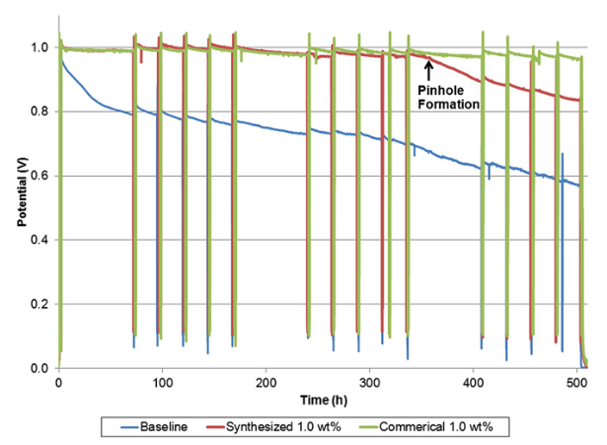

Figure 3: OCV in 500 h AST. Spikes show breaks for electrochemical measurements3

The same trend was observed for the decrease of the FER. The lowest FER was measured for the Cr based samples, but the Mn and Co samples also lead to a reduction of around one half of that of the baseline membranes.

Discussion

The approach of incorporating metals into FC membranes is not new and has shown promising results for some time. Long-term tests have been lacking until now, and the work presented shows that the results are applicable on long timescales, too. Comparing the results though is difficult since different material compositions and preparation techniques were applied. This makes it difficult to attribute the increase in durability and performance solely to the different scavenger approaches. Furthermore, the testing conditions differ slightly from publication to publication. Disregarding these concerns, the work from Lim et al.4 shows the longest lifetime of the presented approaches with 1244 h. Pearman et al.3 tested their MEAs for up to 500 h and stopped the AST. After that the ceria incorporated membranes still performed comparable to the beginning of the AST. This suggests that a much longer lifetime is possible and given the similarity of the two approaches, this would be quite reasonable.

Cerium as a rare earth brings new challenges, such as cost and supply, on a large scale. D'Urso has shown that through appropriate fabrication and the use of transition metals, the function of cerium can be effectively mimicked. They were thus able to extend the lifetime of their membranes to 400h and 600h, respectively.

The same trend was observed in all three publications for the FER. The reduction of ejected fluorite leads to a less damaged membrane and thus contributes to the retention of the mechanical properties.

Although the use of such modified membranes in ASTs shows impressive results, tests under real conditions remain to be done to confirm the true benefit.

Conclusion

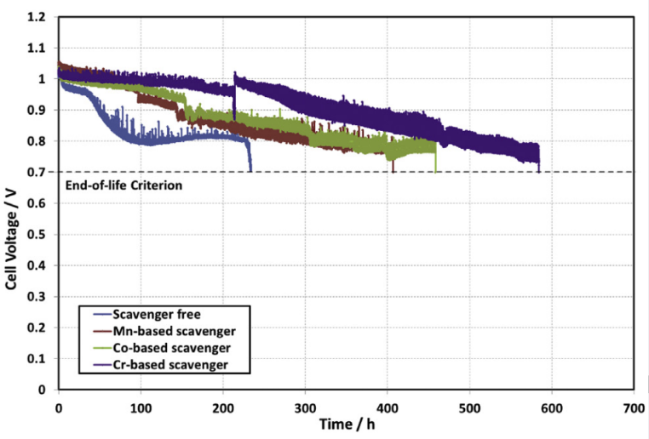

Figure 4: Lifetime comparison between a baseline and Cr, Co and Mn membranes7

The incorporation of transition metal scavengers into membranes shows promising results in increasing the performance of fuel cells. Accelerated stress tests of hundreds of hours prove significant decrease in chemical and mechanical degradations of membranes paving the way to cost-efficient fuel cell technology in a green energy economy. Nonetheless, the complicated underlying processes are still not understood completely. More research and a combination of the here presented methods with different approaches to prevent membrane degradation will need to be found to remove current problems in fuel cells altogether.

**References**

1 W. Grot, *Fluorinated Ionomers*, Elsevier Science & Technology Books, Binghamton, 2nd edn., 2011.

2 M. Zatoń, J. Rozière and D. J. Jones, Current understanding of chemical degradation mechanisms of perfluorosulfonic acid membranes and their mitigation strategies: a review, *Sustainable Energy Fuels*, 2017, **1**, 409–438.

3 B. P. Pearman, N. Mohajeri, R. P. Brooker, M. P. Rodgers, D. K. Slattery, M. D. Hampton, D. A. Cullen and S. Seal, The degradation mitigation effect of cerium oxide in polymer electrolyte membranes in extended fuel cell durability tests, *Journal of Power Sources*, 2013, **225**, 75–83.

4 C. Lim, A. S. Alavijeh, M. Lauritzen, J. Kolodziej, S. Knights and E. Kjeang, Fuel Cell Durability Enhancement with Cerium Oxide under Combined Chemical and Mechanical Membrane Degradation, *ECS Electrochemistry Letters*, 2015, **4**, F29-F31.

5 S. Kundu, M. Fowler, L. C. Simon and R. Abouatallah, Reversible and irreversible degradation in fuel cells during Open Circuit Voltage durability testing, *Journal of Power Sources*, 2008, **182**, 254–258.

6 F. Liu, B. Yi, D. Xing, J. Yu and H. Zhang, Nafion/PTFE composite membranes for fuel cell applications, *Journal of Membrane Science*, 2003, **212**, 213–223.

7 C. D'Urso, C. Oldani, V. Baglio, L. Merlo and A. S. Aricò, Immobilized transition metal-based radical scavengers and their effect on durability of Aquivion® perfluorosulfonic acid membranes, *Journal of Power Sources*, 2016, **301**, 317–325.

8 C. D'Urso, C. Oldani, V. Baglio, L. Merlo and A. S. Aricò, Towards fuel cell membranes with improved lifetime: Aquivion® Perfluorosulfonic Acid membranes containing immobilized radical scavengers, *Journal of Power Sources*, 2014, **272**, 753–758.